Company Name: ENOCTA (AVEZ ELEKTRONIK ILETISIM EGITIM DANISMANLIGI TIC. A.S.)
Company Logo(vectorial):

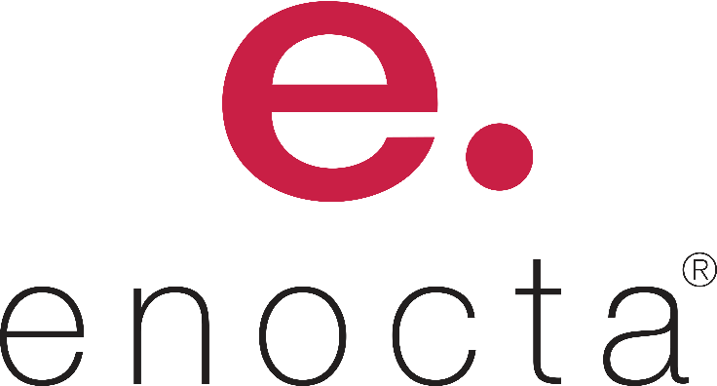
Company Profile:

Enocta is a pioneer and a leading company of Turkey in the field of e-learning.

Founded in 1999 and renamed in 2002, Enocta, Turkey’s pioneer and leading company in e-learning, enhances its products and services with its innovative approach consistently and supports corporate employees in obtaining up-to-date information and competencies that will lead them to their business objectives.

Enocta offers solutions from a single point for more than 500 companies, public institutions and universities for their various needs in training and development.

More than 2 million users follow Enocta’s training programs regularly.

Enocta assist employees in maximizing their performances by accessing the knowledge they need in the fastest and easiest way possible through ‘Enocta Solution Architecture’. Corporations use the e-learning products and solutions of Enocta Solution Architecture as a learning, sharing and communication tool.

+ Course Catalogues
+ Video Collections
+ Podcast Collections
+ Gamification for practice
+ Books, Book Summaries and Articles
+ Custom Content Solutions

Enocta offers standard and result-oriented infrastructure products and services necessary for corporate and academic projects. The learning management infrastructure products, developed for the management of blended learning and synchronous learning processes, guarantee achievement of desired targets and their permanence. Enocta supports the utilization of these products by the corporations in the most effective way.

Corporations with different structures utilize all their learning management and communication activities with these infrastructure products and services.
+ Enocta Learning Platform
+ Enocta Academic Learning Platform
+ Virtual Classroom
+ Video Learning Portal
+ Integration Services

